Dear Sir/Madam,
We hereby acknowledge receipt of the Allocation Letter for Region 5 and confirm our formal acceptance of the appointment.
We appreciate the opportunity and confirm our commitment to executing the scope of work in accordance with the terms and conditions stipulated in the allocation letter.
Kindly advise on any further documentation or commencement requirements.
Yours faithfully,
For and on behalf of
Sithembe Transportation and Projects

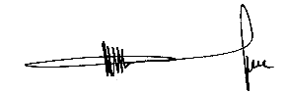
Muzi Vincent Lukhele
Director

